Redmond_Ben_200412111_ Web Design & Development

CA_ONE

This project aimed to design a brochure website for a Bed & Breakfast Business in Galway City.  
  
I started with the overall design of the website using Figma, making a wireframe of the website and indicating where I wanted content and page layout.

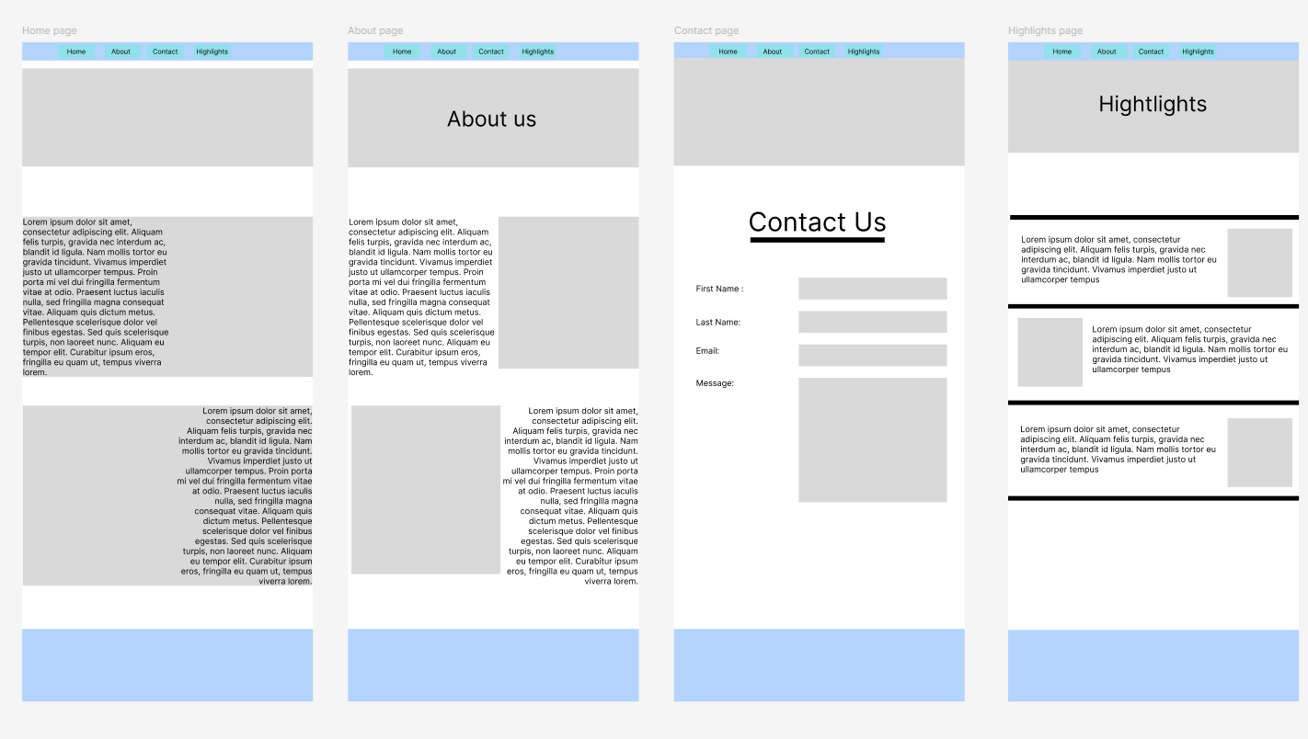

For this project, I started using GitHub Desktop. Just so I would have a quick way of updating what I was doing, and my work could be remote. Here is a link to my repo   
<https://github.com/BenRedmondgithub/20041211_Redmond_Ben_WebDev-project>

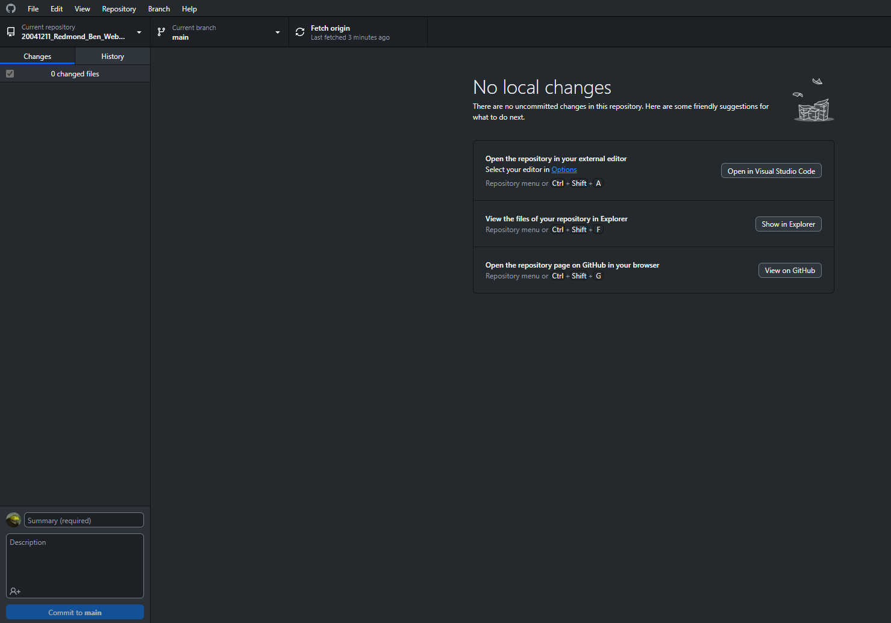

The very first thing I did was set up the Navbar with links to all the other pages the next was to create a div to hold the hero image and the H1 In place, the Navbar and the main text on screen using Merienda linked with Google fonts, here is a link to the font.

<https://fonts.google.com/specimen/Merienda?query=Merienda>

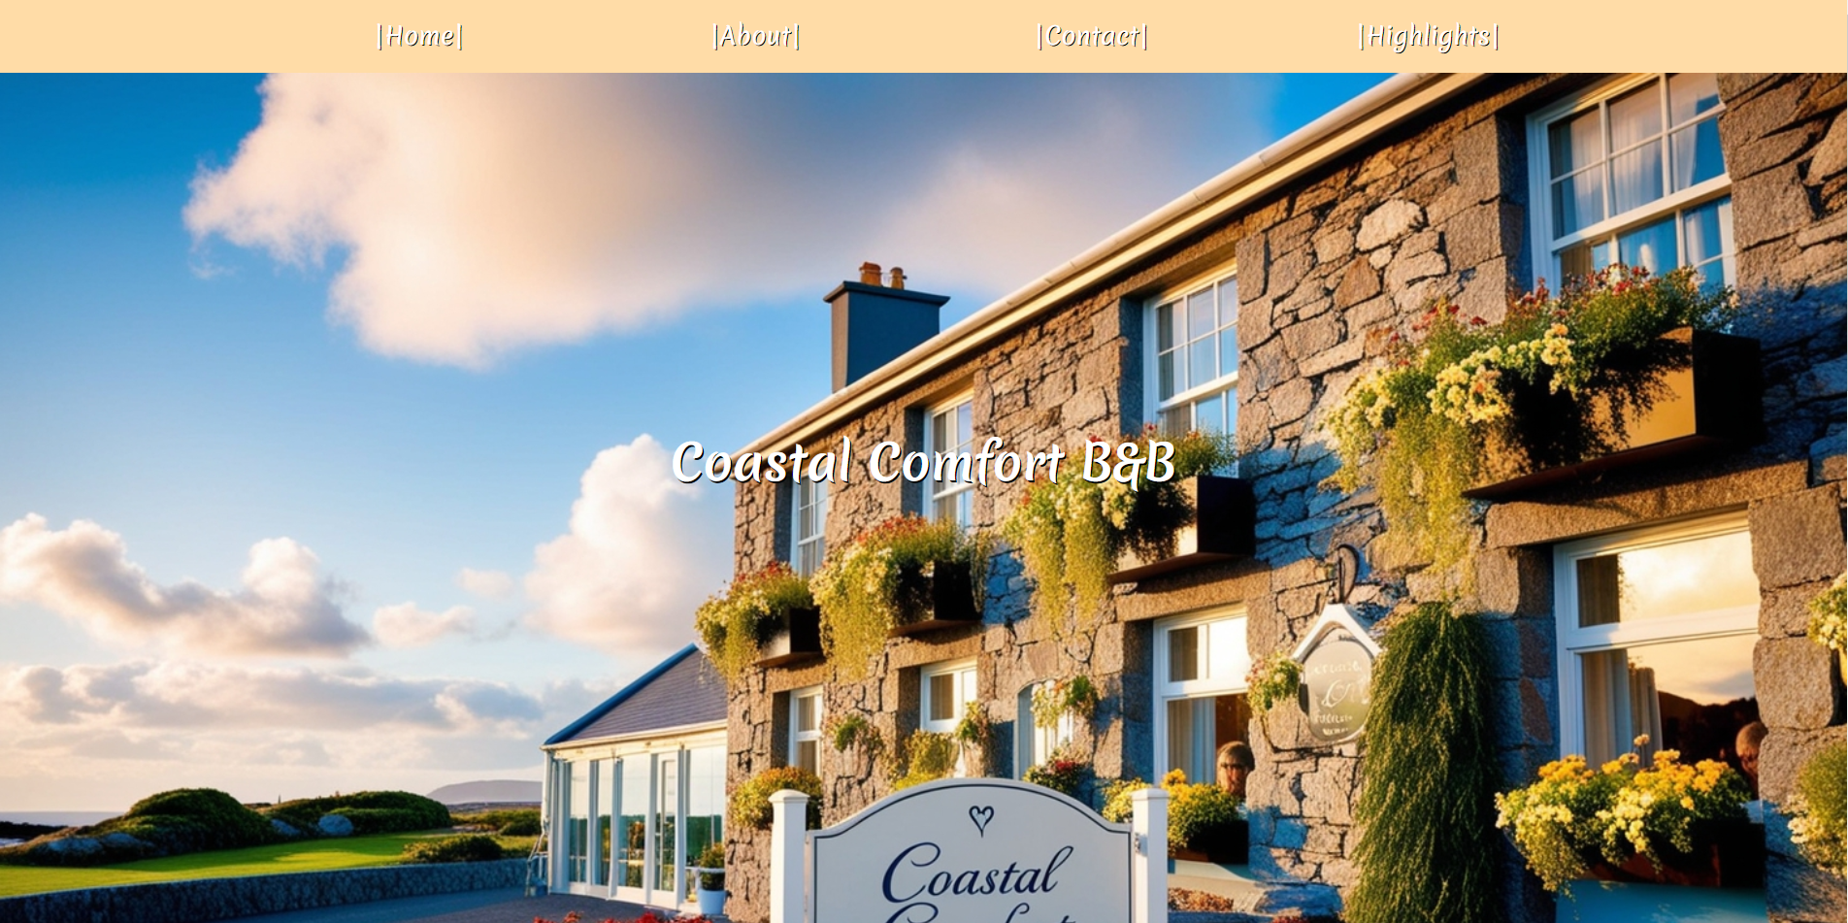

Then, I used the main tag and created two divs with text and two images, one image on the right with text on the left and the other the opposite way. It was a bit hard to understand how the images would work if you used float left and right.

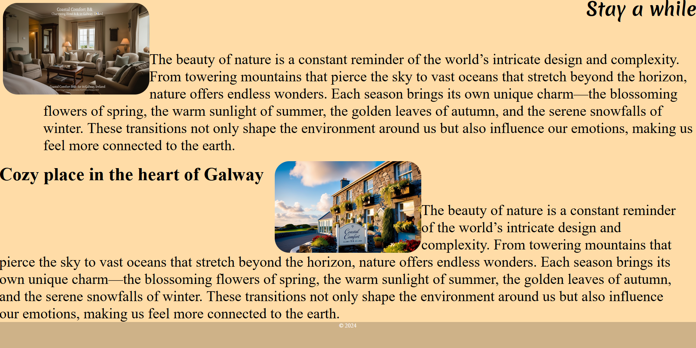

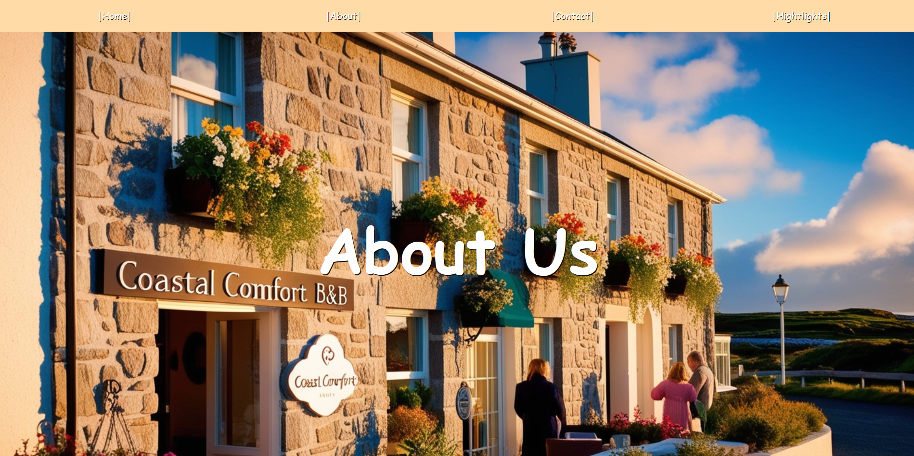

Then, I started the About Us page. This page is for the public to get to know the owners and how they are. However, this hero image is different from the main home page image. I started using background images in my CSS and put the background image within the first div. I found it hard to change the Homepage if the Hero image was in the first div. The background image helped me very much in that regard.

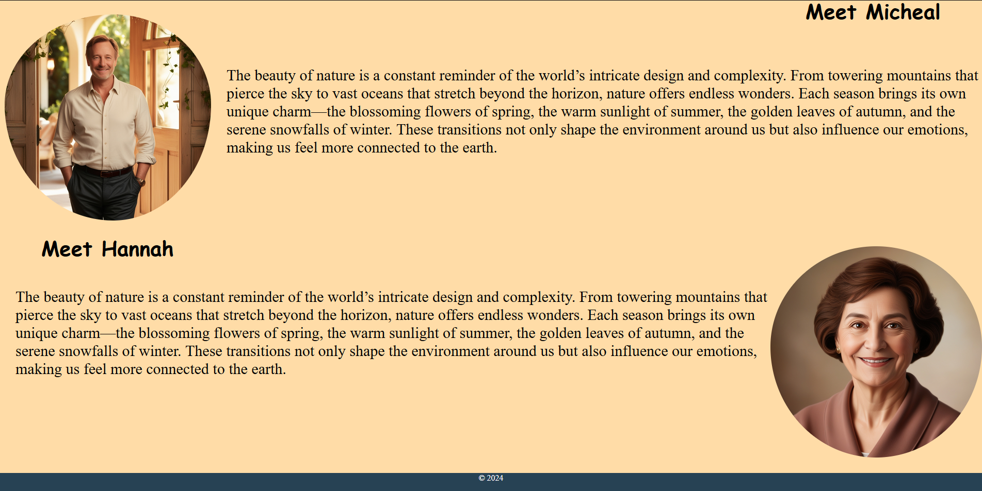

For this part of the About page, I used the same code as I used on the home page and just replaced the images and text on the page. I got these portraits from the internet and just rounded off the edges using border-radius at 50%;

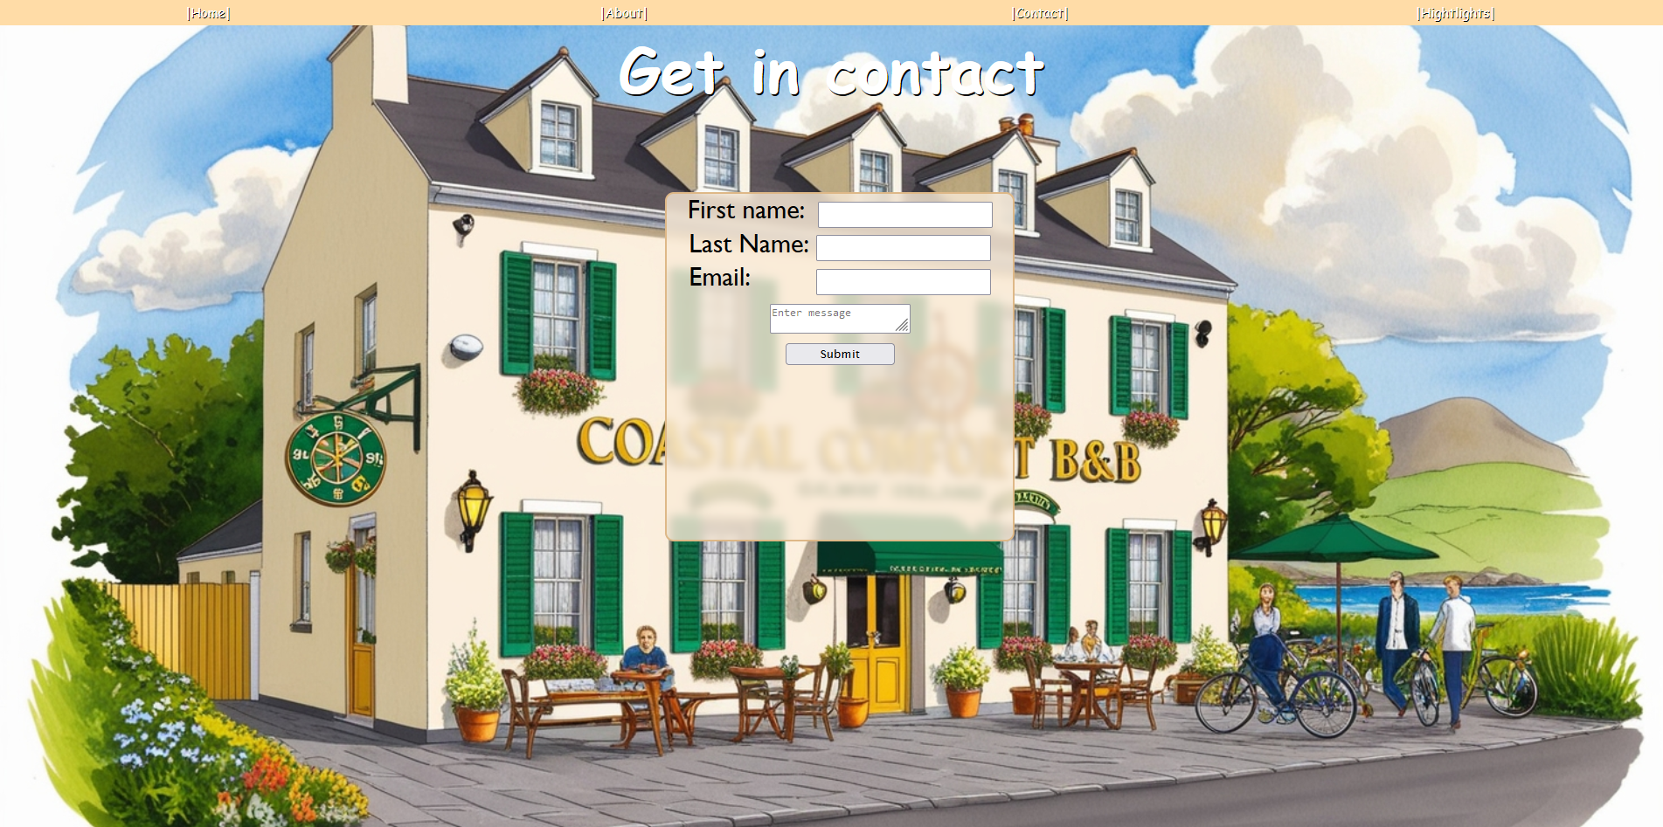

I learned from setting a background image on the last page and used the same code. The form needed input for First name, Last name, email, and a message box. I learned that you can make a glass-like div effect, I just wanted to see what it looked like and I liked it so much it stayed there. I think it’s a good effect.

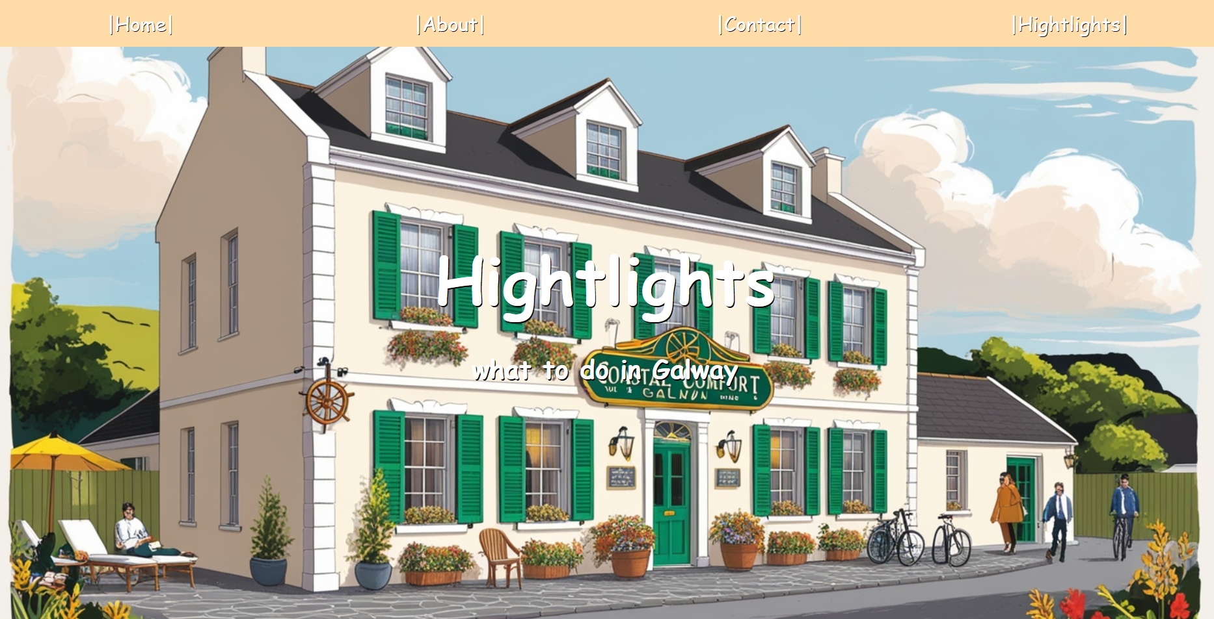

The Highlight page is for highlighting what to do in Galway, and it’s more of the same layout on the second and third pages using a background-image instead of the Home page, where I put it in a div.

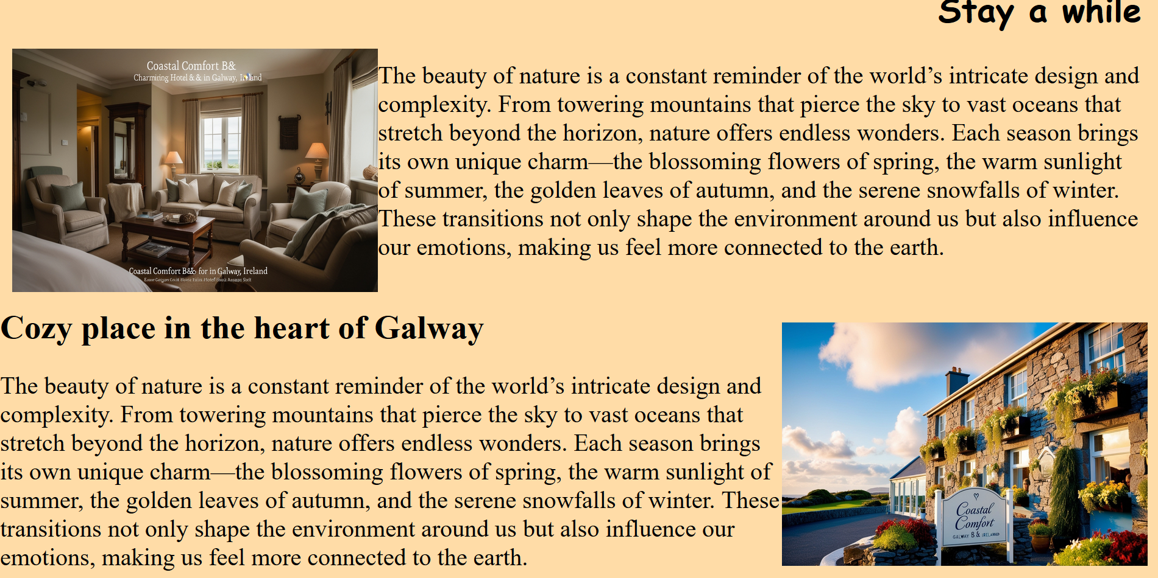

Same again for these div and text here, just used the same code and I did before and at the end for the page too.